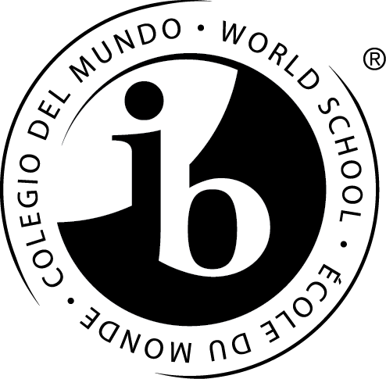
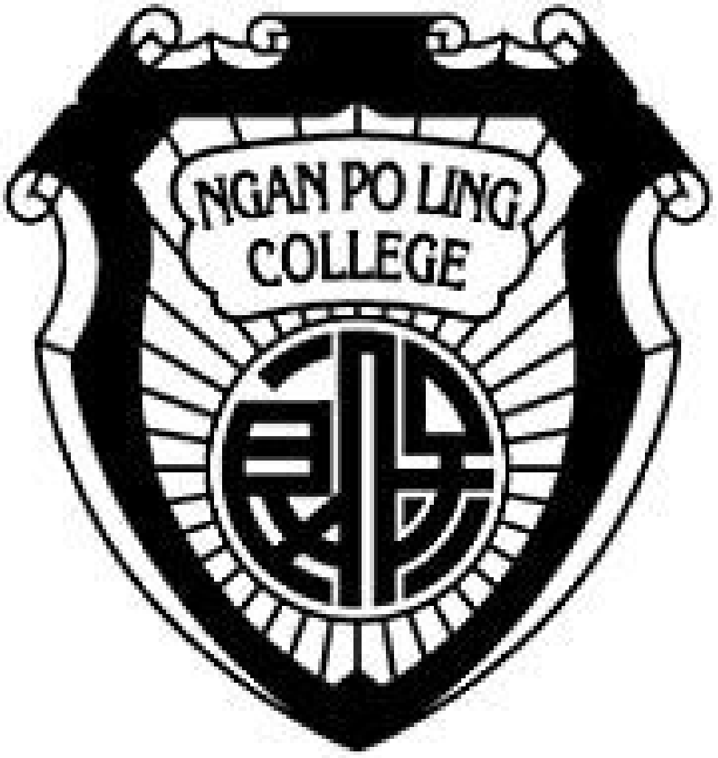 | Po Leung Kuk Ngan Po Ling College  保良局顏寶鈴書院  26 Sung On Street, Tokwawan, Kowloon  九龍土瓜灣崇安街26號  Tel 電話： 2462 3932 Fax 傳真： 2462 3929

 | International Baccalaureate (IB) Diploma Programme  Bridging Year Programme Application Form  2026–2027 (For Internal Students Only) | Application No.
 |  | Date Received

Name of Student |  | (Surname) (Given name) |  |  |  |  | 學生姓名 |  |  | (姓) (名)
Sex |  | Age |  | Nationality |  |  |  |  | Ethnicity
Spoken Language at Home |  |  |  | First Language |  |  |  |  | Second Language
Date of Birth  (dd-mm-yy) |  |  |  |  |  |  |  |  |  |  |  | Please affix  recent photo
HKID Card No.
Correspondence  Address | Flat |  | Floor | Block/Building
Correspondence  Address | Estate/Village
Correspondence  Address | Street |  |  |  | District
Telephone No. | Home |  |  |  |  | Mobile
E-mail
Previous  School(s) | Name of the School |  |  |  |  | Class |  | Conduct |  |  | Position in Form |  | School Year
Previous  School(s) |  |  |  |  |  |  |  |  |  |  |  |  | –
Previous  School(s) |  |  |  |  |  |  |  |  |  |  |  |  | –
Previous  School(s) |  |  |  |  |  |  |  |  |  |  |  |  | –
Extra-Curricular Activities | Year |  |  | Descriptions
Awards obtained

 | Father | Mother | Guardian
Name in Full
Occupation & Position
Name of Company
Education Level
Contact No.

Choice of subjects:
Please indicate your preference over the subject stream choice and please mark ‘1-4’ with 1 as the most preferred choice.
Science |  |  | Arts
English |  |  | English
Chinese / French* |  |  | Chinese / French*
Economics / Geography* |  |  | Visual Arts
Chemistry |  |  | Economics / Geography*
Biology / Physics* |  |  | Biology / Physics*
Mathematics |  |  | Mathematics
Engineering |  |  | Business / Social Science
English |  |  | English
Chinese / French* |  |  | Chinese / French*
Economics / Geography* |  |  | Economics
Chemistry / Geography* |  |  | Geography
Physics |  |  | Biology / Physics*
Mathematics |  |  | Mathematics

*Please delete the inappropriate for the subject options.

Note:
- Depending on the number of enrolment for each combination, all subject combinations will be subject to change.
- French is only available for non-Chinese students.
- A subject will be offered only if there are at least 5 students opting for it.

I declare that to the best of my knowledge and believe the information listed in this form is true and correct.
If false information is provided, the application will be rendered null and void.

Name of Parent/ guardian | : |  | Signature of Parent/ guardian | :
 |  |  | Date | :

Remarks on Application Form Submission
Students of Po Leung Kuk Ngan Po Ling College should submit the completed application form THROUGH ECLASS EMAIL to ib@home.npl.edu.hk.

Remarks on Application of School Fee Remission
Details for the school fee remission can be obtained from:
https://www.npl.edu.hk/en/site/view?name=2526+Scheme
Newly admitted students could apply for the school fee remission within 4 weeks after the commencement of the new school year.
The completed application form, together with all required documents, must be submitted IN PERSON to Po Leung Kuk Ngan Po Ling College.
(Application made by post or fax will NOT be entertained) For school fee remission enquiries, please contact us at 2462 3932.

For further details about the IB Diploma Programme you can write to:
IBDP Coordinator: Ms. Iu Yiu at yiu@home.npl.edu.hk.

